PROJECT DEVELOPMENT- DELIVERY OF SPRINT

TEAM ID: PNT2022TMID18845

PROJECT DEVELOPMENT-DELIVERY OF SPRINT:

Sprints are **time-boxed periods of one week to one month, during which a product owner, scrum master, and scrum team work to complete a specific product addition**. During a sprint, work is done to create new features based on the user stories and backlog.

sprint (software development)

The development team has the final say when it comes to determining how much work can realistically be accomplished during the sprint, and the product owner has the final say on what criteria

need to be met for the work to be approved and accepted.

## Sprint roles, artifacts and ceremonies

A variety of roles are involved in a sprint, with each working on different parts of the process.

[**Product owner**](https://www.techtarget.com/searchsoftwarequality/definition/product-owner)**:** This person represents the business or user community and is a liaison between the development team and customers.

**Scrum master**: This person is the main facilitator for the project’s development team. They manage the process for how information is exchanged during the sprint, including leading stand-up meetings and helping the team stay on track by mediating problems and removing obstacles.

**Scrum team**: This group of people is responsible for executing the work. In addition to developers, the scrum team can contain testers, architects, designers and [IT operations](https://www.techtarget.com/searchitoperations/definition/IT-operations) While the scrum master is charged with protecting the team and keeping focus, the team itself is self-managed and ultimately responsible for collectively determining how to reach their goals.

* [Backlog](https://www.techtarget.com/searchsoftwarequality/definition/product-backlog-grooming)
* [Burn down charts](https://www.techtarget.com/searchsoftwarequality/definition/burn-down-chart)
* [User stories](https://www.techtarget.com/searchsoftwarequality/definition/user-story)

Ceremonies are meetings that are held for every sprint. Ceremonies include:

* Sprint planning meeting
* Daily scrum or daily stand-up meeting
* Sprint review
* Sprint or [Agile retrospective](https://www.techtarget.com/searchsoftwarequality/definition/Agile-retrospective)

## Sprint workflow and process

The sprint workflow is intended to help team members evaluate their work and communicate with each other throughout the entire process. The workflow is followed for each sprint. The process includes:

* **Backlog** - A list of set tasks that must be completed before the product is released. The backlog is built by the product owner. The product owner gives a backlog of prioritized items to the scrum master and scrum team. The backlog is based on user stories, which focus on features that consider the type of end user, what they want and why.
* **Sprint planning** - The team discusses top priority user stories and decides what can be delivered in the sprint.
* **Sprint backlog** - Agreed upon by the entire team, this list finalizes and defines what the development team will complete during the sprint.
* **Sprint** – The time frame in which the work must be completed – often 30 days.
* **Daily scrum** – Lead by the scrum master, the team comes together for short daily meetings, in which they discuss what they have completed, what they are working on and any issues that are blocking the work.
* **Outcome** - The outcome of a sprint is a hypothetically usable product. The product owner can decide if the product is ready or if additional features are needed.
* **Sprint end** - At the end of a sprint, two meetings are held:
  + **Sprint review** – The team shows their work to the product owner.
  + **Sprint retrospective** – The team discusses what they can do to improve processes. An important goal is [continuous improvement](https://www.techtarget.com/searcherp/definition/kaizen-or-continuous-improvement).

**Scrum vs. sprint**

Scrum is the specific, framework used under the Agile umbrella to develop complex products. The

term *scrum* is also used to describe the daily, standup meetings that occur during a sprint.

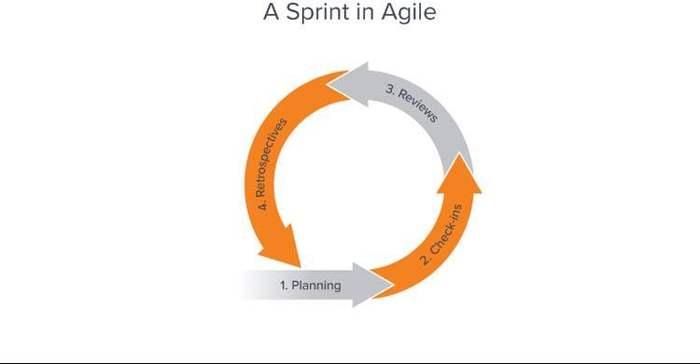

# Sprint planning.

Setting up a sprint requires proper [sprint planning](https://www.workfront.com/project-management/methodologies/scrum/sprint-planning). This is the project manager’s chance to decide on objectives and actions for an upcoming sprint. The project manager gathers the team to determine:

# Sprint review.

Once a sprint is completed, the project manager hosts a [sprint review meeting](https://www.workfront.com/project-management/methodologies/scrum/sprint-reviews) with all team members and stakeholders to:

* Demonstrate sprint outputs
* Determine what was accomplished and what wasn’t
* Review project forecasts

# Sprint retrospective.

The final step in the sprint project management process is the [sprint retrospective](https://www.workfront.com/project-management/methodologies/scrum/sprint-retrospective). This takes place after the sprint review and before the next sprint planning session.